](https://soundofstars.org/welcome/)

[](http://soundofstars.org/regularity.htm#disclaimer)



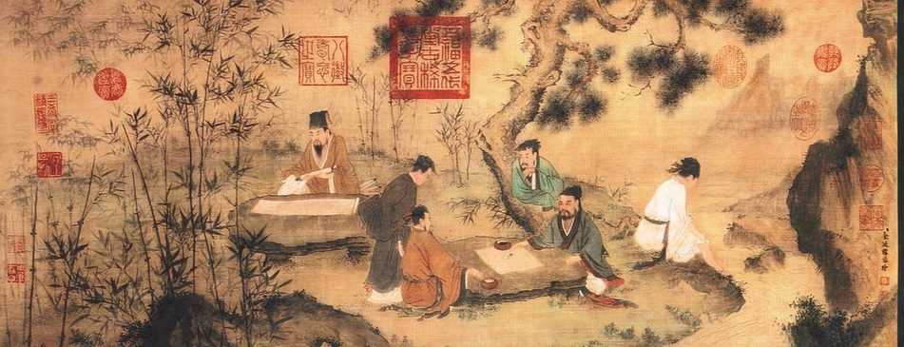

**In ancient China ; The pupil was instructed to visit a village, perhaps it was a village**

**on the far flung outreaches of a far away and remote village, one in which the Emperors envoys**

**only checked in irregularly.  The pupil was to go to the village to seek out and discover what**

**state the community was in overall and then to report its status back to his teacher, where**

**upon the Master would then take the findings to inner council of the Emperor.**

**Upon arriving at the designated village, the task was to walk, on foot, to its center upon sunrise.**

**Once at this location the pupil would find some area to comfortable sit and then he would close**

**his eyes and simply listen.**

**All day he would sit until after sunset, listening, his eyes closed all day long.**

**During this time, and from his arduous and length training of observance, the pupil would soak**

**in all sounds coming in from all over the village, the sounds close by and far away.  He would**

**listen to the sounds of children laughing, playing, mothers speaking, merchants shouting, people**

**arguing, the movement of resources, the sound of equipment being used in foundries, the sound**

**of the wind, and of course the back ground tones and din of the collective amalgamated noise**

**made by all and everything.**

**Shortly after sunset, like a medical wise-man taking the pulse on the wrist of a patient, the pupil**

**would ascertain and diagnose the energetic pulse of the village and by this diagnosis would**

**know intimately if famine was close, if rebellion was brewing, if chaos or harmony would be**

**encountered within weeks or months..**

**The reason that I share this story with you is this ;**

**Over many years I have found that the fundamental principle outlined in this story is absolutely**

**true and of extreme importance and benefit to the one willing to gain the insight and master the**

**associated disciplines, certainly I know I have personally gained immensely by this.**

**However there is more to this story or rather there is much more to the set of dynamics involved.**

**The ‘Greeks’ had a word called ‘Kairos’, it means the ‘right moment’.  I have found that when one**

**can understand and combine the ‘right time’ with the ‘right place’, wondrous things may be**

**observed, enormous advantages may be gained, great things may be accomplished and great**

**evils may be avoided or at least dampened.**

**There is admittedly a complex craft involved, however various summations may be derived and**

**simplified for simple and rapid practical applications, even by the common person, if they but**

**have some degree of access to the information, even when and if that information is brief.**

**There are various tools and methods, some known by the public to various degrees and some**

**not known that can be used in this pursuit.**

**Commonly known ones are those such as ’[astrocartography](http://en.wikipedia.org/wiki/Astrocartography)’, various forms of ‘**[**geomancy**](http://en.wikipedia.org/wiki/Geomancy)**’,**

**‘**[**feng shui**](http://en.wikipedia.org/wiki/Feng_shui)**’ and the like were used to ascertain the dynamic energies occupying space.  These**

**energies however could at times change over time and often did and then different arts and**

**sciences would be used to measure and analyze the nature of the ‘time’ component.**

**While I made a rigorous effort to understand these crafts, in the end, I designed my own unique**

**approach to being able to ascertain what the specific energies affecting a person, a place, a time**

**and of course even a person AT a certain place AT a certain time would be.**

**One of the authors I have enjoyed in my journeys over the years is Thomas Váczy Hightower.**

**It may have been ten years ago or more that I came across his writings.  I share some excerpts**

**of his here now with you and I encourage you to visit his website.  I trust you enjoy the following ;**

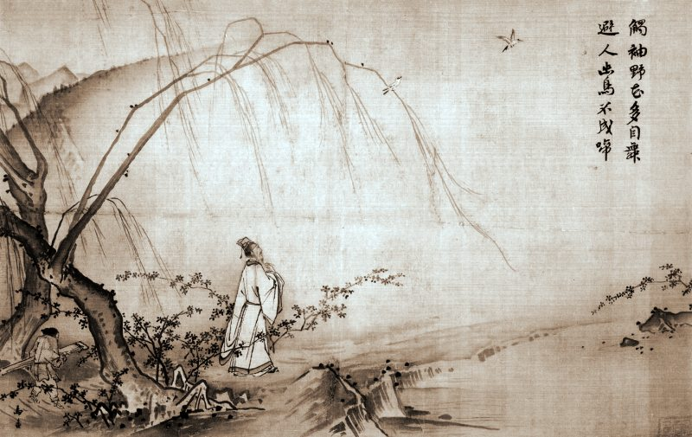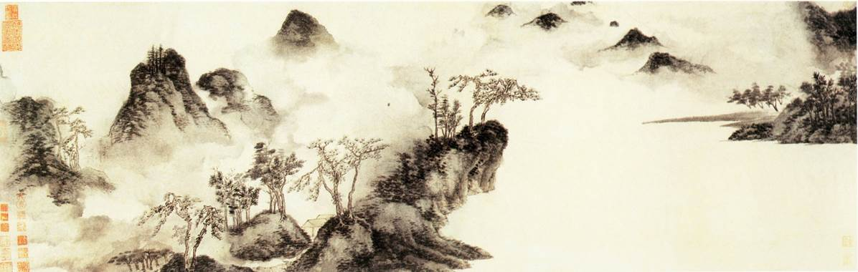

**Writings of**

**Thomas Váczy Hightower**

[**Tuning the Sacred Kung**](http://vaczy.dk/htm/scales2.htm)

**The alignment of earth with heaven, and man with the Supreme, was literally the**

**purpose of life. The entire order and affairs of the State were dependent upon the**

**right tuning of the fundamental tone, the ‘yellow bell’, or Kung.**

For the ancient Chinese, the alignment with the divine prime tone was the Emperor's most important task.



As an ancient text warns: “If the Kung is disturbed, then there is disorganization; the prince is arrogant.”

If the Kung was out of tune, because the celestial realm has changed, disorder and inharmonious behavior

in society became obvious. Every instrument (including measuring instruments) was tuned and utilized in

accordance with the holy tone.

The instrument that could give to man the fundamental tone for a musical scale in perfect harmony with the

universe was the key to earthly paradise, and essential to the security and evolution of society. It became the

Chinese Holy Grail.

One legend tells of the amazing journey of Ling Lun, a minister of the second legendary Chinese Emperor,

Huang Ti. Ling Lun was sent like an ancient Knight of King Arthur to search for a special and unique set of

bamboo pipes. These pipes were so perfect that they could render the precise standard pitches to which all

other instruments throughout the land could be tuned.

That sacred tone, which relates to the Western modern pitch of F, was considered as the fundamental cosmic

tone. The Chinese were aware of the slow changing cosmic influence, and consequently the Kung has to

change accordingly. The Emperor had the task of tuning the Kung so it was in alignment with the cosmic tone.

**…..**

[**PHENOMENAL ASPECTS**](http://vaczy.dk/htm/society.htm)

[**of Music and Society**](http://vaczy.dk/htm/society.htm)

·                     **The phases of masculine and feminine influence**

·                     **The Cycle of Sex**

·                     **The fatherless society**

·                     **The dream Society**

·                     **The BNP of happiness**

·                     **The question of good and evil**

·                     **The break from Antiquity**

·                     **The treachery of transcendence**

[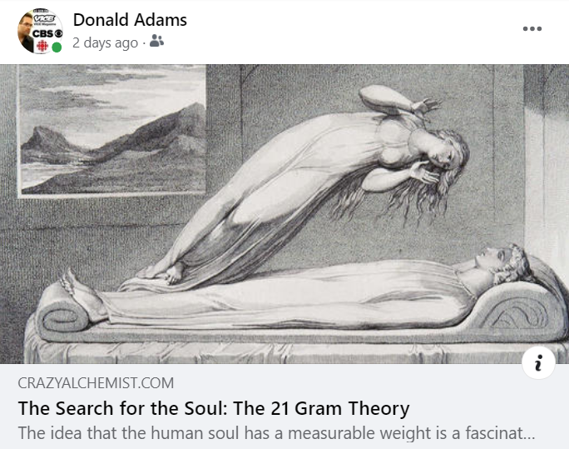](https://www.crazyalchemist.com/the-search-for-the-soul-the-21-gram-theory)

is a fascinating concept that has occupied both scientists and philosophers for centuries. One of the most famous studies on this topic is the "21 Grams" experiment conducted by physician Duncan MacDougall in 1907. MacDougall postulated that souls have a physical weight and attempted to measure the mass a person loses when they leave the soul. MacDougall's experiment was simple but controversial. He placed six dying patients whose death was imminent on an industrial scale accurate to two-tenths of an ounce (5.6 grams). In one of the patients, he found that the weight decreased by about 21 grams immediately after death. MacDougall claimed that this was the weight of the soul.

[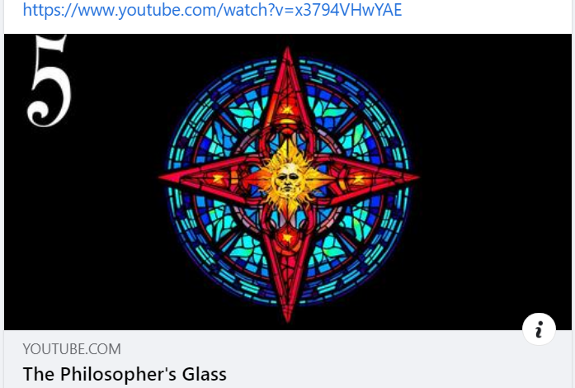](https://www.youtube.com/watch?v=x3794VHwYAE)

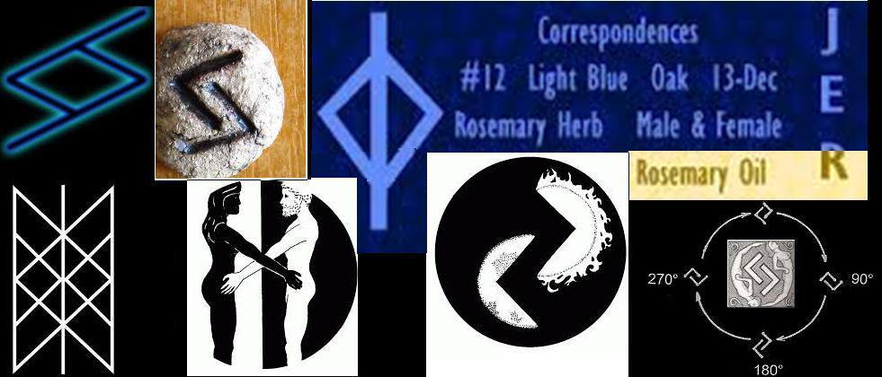

Jera has to do with right timing. #12 & **Light Blue the key to understanding the mysteries of time and the**

**psychological importance of dividing and managing time**.

Deadlines bring out the best in us and motivate us to grow to levels beyond our present ability. It also moves us to

strategically taking action when the time is right. Take advantage of the ups and coast through the downs.

Jera can magically speed things up or slow things down, and manipulation of subjective time in this manner is governed by this rune.

“Patience up to a point. Know your time, but work your wyrd always.”

Jera may also represent that little extra push that one needs to finish a job -- that final motivation that sees a job through

to its successful conclusion.

Rune of harvest and reward for, or reaction to, right actions in a horizontal (naturally ordered) cyclical process. Rune of peace on the land and in the heart.

Psi: psychological time, patience, the measurement of time Energy: good harvest, orbits, cycles, progress, biorhythms, right effort

Mundane: waiting, gardening, farming, the seasons, harvest

Divinations: Reward for positive action, plenty, peace, proper timing;

or repetition, bad timing, poverty, conflict, regression.

Governs:

Fertility, creativity and harmony with the land

Peace, prosperity and plenty

Realization of the cyclical nature of the multiverse, invoking the

power of time and cycles

Bringing other concepts gently into material manifestation

Initiating gradual and lasting change in flow of life

[http://www.runemaker.com/futhark/jera.shtml](http://www.runemaker.com/futhark/jera.shtml?fbclid=IwAR2DFjTguNYd6zxMU-gngBfTg3J7QvXi2GHN_8zMvmQTsOL6G03DQntUC6I)

[http://www.ifate.com/rune_ex_full/ex12.html](https://l.facebook.com/l.php?u=http%3A%2F%2Fwww.ifate.com%2Frune_ex_full%2Fex12.html%3Ffbclid%3DIwAR0eGpfCioQReicZi5JfoYbX2IZ4Yfy_EXaDmaNgQkew3gRImCi6F-NZ0Os&h=AT3NAnc4duz2I7EB23d6Ux7YxVtSEgm5EC5ZT2IwV_CCLM5h0Uh9eh7whPko2ludpCtSEPRUfWZvWQp-PlspeqLgxhDm0HpK_WqlKJxoLPHSsb-pzWbNA5VegdCO9EiXmaxGhIKnIRqghf5u9sPG&__tn__=-UKH-R&c%5b0%5d=AT20Y_iGcm-zUdjF5ksT9QsjOjKDpBzq0c5nhHQTsbne4yErSoLBWHK1_hBJPTCVZasohatRr4rJIcP5ostlnRy16x8Gb6f-_cwfZrJBJXi_pSD3QTciZYsrFLGLNCiiShakSVL7-jEUOK2TSHT3O-irsp8RD9-VVWr2f1TQxckJG5iJFPn35cNMZmKYLmT8NX0Udm43)

[http://runesecrets.com/rune-meanings/jera](http://runesecrets.com/rune-meanings/jera?fbclid=IwAR2Nl10a-lEyie_GSlGjuEK_Dtn4twNbkCkmM6m7zZpbrKx6o0KyEwVaGjI)

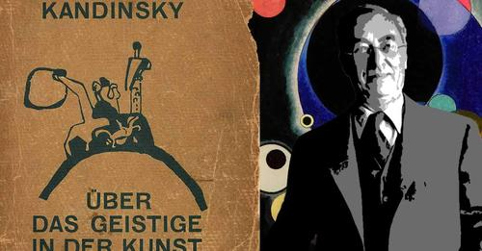

Kandinsky was deeply attuned to the spiritual resonances of color, and they became a defining principle in his art. In Concerning the Spiritual in Art, Kandinsky describes color as a gateway into the metaphysical, spiritual realm. He describes how individual colors each have their own emotive and resonant properties. **Blue, in particular, held great significance for Kandinsky, as he writes, “The deeper the blue becomes, the more strongly it calls man towards the infinite, awakening in him a desire for the pure and, finally, for the supernatural…”** Kandinsky also described how sonorous combinations of colors could invoke mixed emotional responses and reach deep inside the viewer and touch their inner psyche, writing: “Color is a power which directly influences the soul.”

Kandinsky was entranced by the transformative potential of music, particularly its power to lift the listener’s mind out of everyday reality and into a dream or trance-like realm. In Concerning the Spiritual in Art, Kandinsky writes, “A painter, who finds no satisfaction in mere representation, however artistic, in his longing to express his inner life, cannot but envy the ease with which music, the most non-material of the arts today, achieves this end.” Kandinsky’s greatest artistic challenge then, was to find ways of expressing sonorous musicality through art. He draws comparisons between the two creative disciplines in Concerning the Spiritual, writing, “Color is the keyboard, the eyes are the harmonies, the soul is the piano with many strings. The artist is the hand that plays, touching one key or another, to cause vibrations in the soul.”

[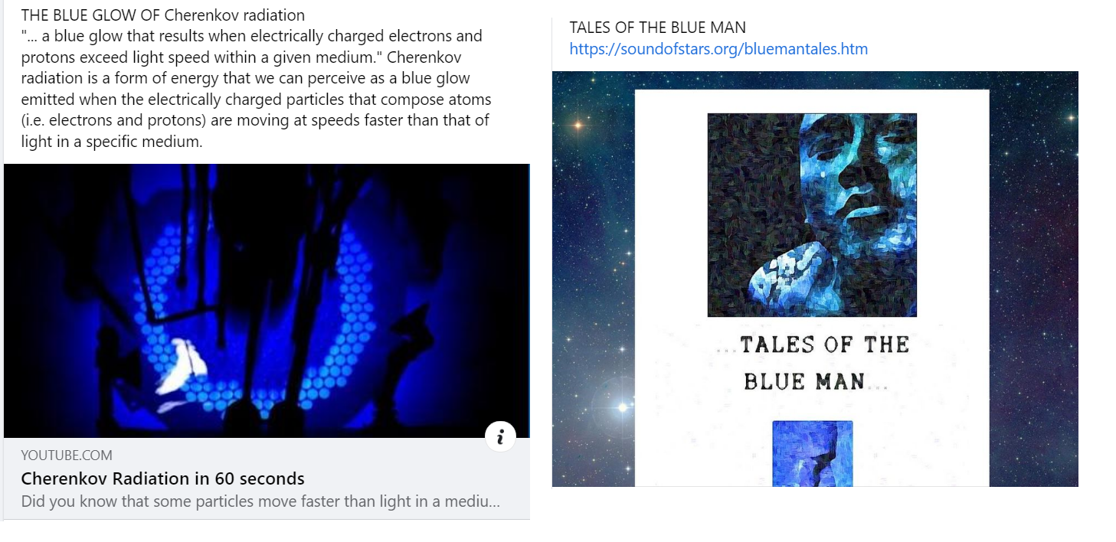](https://soundofstars.org/bluemantales.htm)

[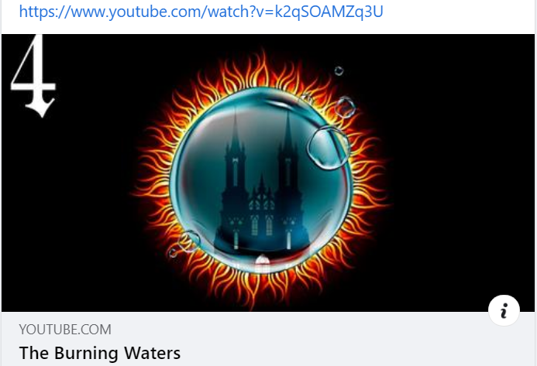](https://www.youtube.com/watch?v=k2qSOAMZq3U)

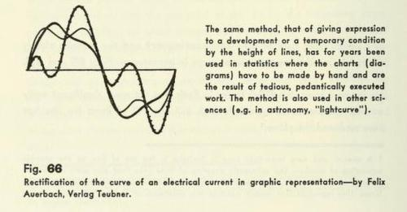

[https://twitter.com/EdwardTufte/status/827910123758706689](https://twitter.com/EdwardTufte/status/827910123758706689?fbclid=IwAR2HLj-366kB_oJIGI9-1xwym5L6-Ye3WZ9f3zIbePvAUY8h1hSsaarth8g)

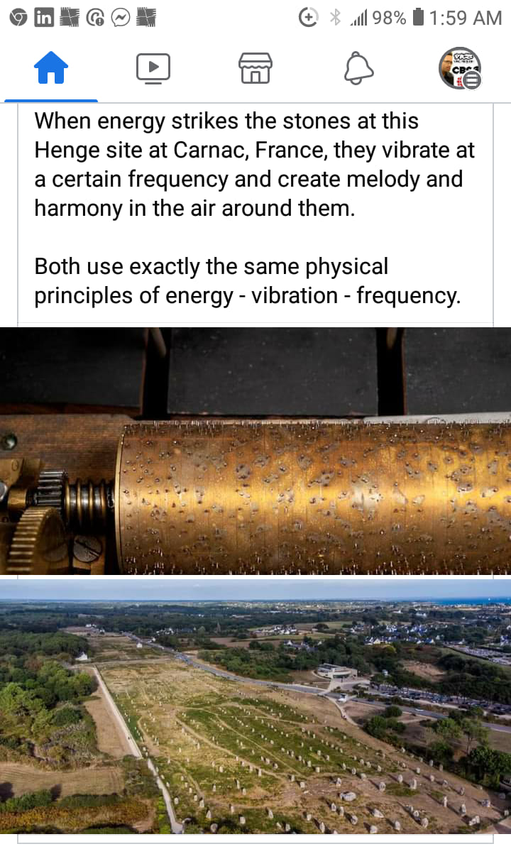

**CROP CIRCLES ENCODE MUSICAL DIATONIC RATIOS**

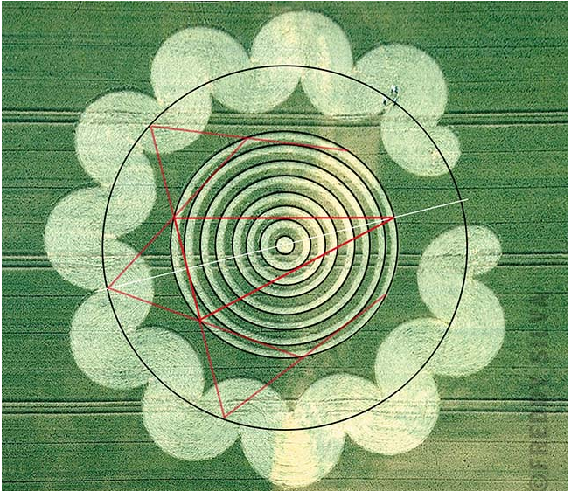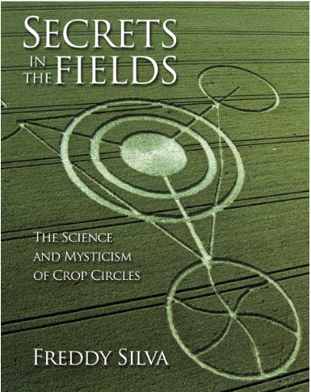

In 1990 the astronomer and mathematician Gerald Hawkins discovered that the early crop circles encoded diatonic ratios, what musicologists refer to as the perfect intervals of the music scale. According to Hawkins’ calculations, the chances of this happening by accident are 1:400,000. “It’s so difficult to make a diatonic ratio, even more so in the dark. It has to be laid out accurately, to within a few inches with a forty-foot circle, for example.” And by 1995, crop circles measuring up to 300 feet were containing diatonic ratios to within a few inches of accuracy.

[**https://invisibletemple.com/book-crop-circles-secrets-in-the-fields.html**](https://invisibletemple.com/book-crop-circles-secrets-in-the-fields.html)

This prompted him to look for geometrical relationships between the circles using Euclidean geometry. Euclid was a Greek mathematician of the third century BC. whose thirteen-book treatise on mathematics established the basic rules and techniques of the geometry that now bears his name. Hawkins analyzed the crop circles again and found they contained four new theorems. “These are Euclidean theorems,” he remarked, “but they are not in Euclid’s books.”

This was significant because the crop circle theorems also contained diatonic ratios as a natural byproduct of their geometry. The implication was that whoever made the circles was intellectually on a par with, or superior to, Euclid.

Then almost by accident he discovered a fifth, more general theorem from which all the others were derived. To demonstrate how hard it is to conceive of a mathematical theorem, Hawkins dangled this brain-numbing puzzle in front of the 267,000 worldwide readers of Science News. The idea was to challenge scientists and mathematicians to create, given the other four, this fifth theorem. None figured it out. A further challenge to readers of Mathematics Teacher proved equally fruitless. Then in 1995, a version of the theorem appeared, encoded into this ‘torc’ crop circle at Litchfield.

**Source. Secrets In The Fields :**<https://invisibletemple.com/book-crop-circles-secrets-in-the-fields.html>

[Crop Circles: Evidence Of Intelligence](https://vimeo.com/ondemand/cropcircleevidence)

[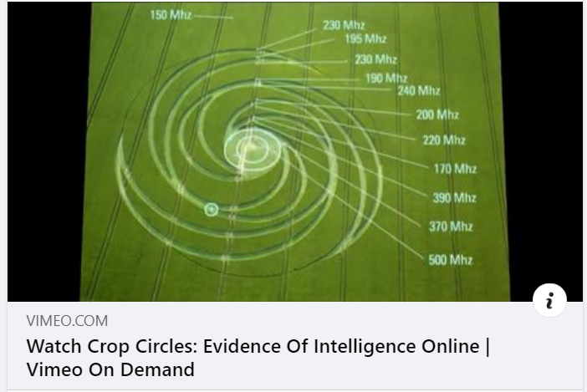](https://vimeo.com/ondemand/cropcircleevidence)

[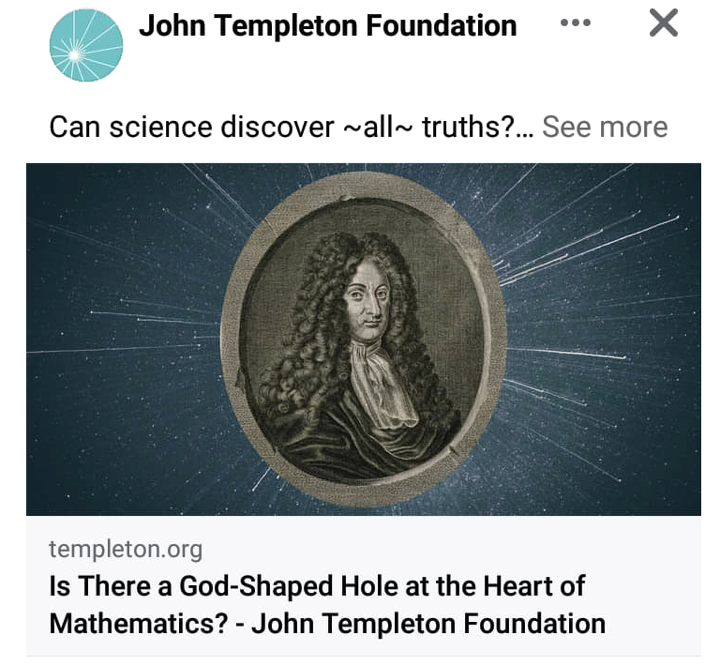](https://www.templeton.org/news/is-there-a-god-shaped-hole-at-the-heart-of-mathematics)

Gödel developed a mathematical proof to demonstrate God’s existence. Viewing himself as a successor to Leibniz, Gödel’s proof elaborated upon the ontological proof of his predecessor. Gödel sought to fix the fundamental weaknesses of and remove inconsistencies from Leibniz’s proof. Gödel’s proof addresses all of the classic philosophical criticisms of Anselm’s, Descartes’, and Leibniz’s ontological proofs, and also addresses Kant’s well-known objection that existence should not be treated as a predicate.  
  
Gödel’s ontological proof uses mathematical logic to show that the existence of God is a necessary truth. “God” in Gödel’s proof is defined as a “Godlike object”. In order for an object to be “Godlike”, it must have every good or positive property. Also, a Godlike object has no negative properties. In the context of Gödel’s proof, an object (x) has “the Godlike property” if and only if for every property (φ), if φ is a positive property, then x has property φ. Because being “Godlike” is a positive property, it is possible that that property exists in an object (x). After mathematically defining essential or necessary properties Gödel then shows that it is necessary that there is an object x that has the Godlike property. If a Godlike object (i.e. God) has every good property, and necessary existence is a good property, then a Godlike object (i.e. God) must exist. In time, the fruit of Leibniz’s binary theory, AI, would demonstrate the consistency of Gödel’s ontological proof. One team of AI researchers concluded that “From Gödel’s premises, the computer proved: necessarily, there exists God” and also that “this God-like entity is unique, i.e. monotheism is a consequence of Gödel’s theory.” Such experiments, the researchers declared, “strikingly demonstrate the potential benefits of a computational metaphysics…in which humans and computer programs join forces in order to settle philosophical disputes,” thus fulfilling “Leibniz’s vision known as ‘Calculemus!’” Yet, the results of such AI calculations about metaphysics still rely on fundamental assumptions regarding the mathematical axioms that one assumes in the first place. Thus, the only weak point in Gödel’s ontological proof for the existence of God would appear to be Gödel’s own incompleteness theorems proving the limited and unprovable nature of all mathematical endeavors. But this, of course, would come as no surprise to Gödel.   
  
<https://www.templeton.org/news/is-there-a-god-shaped-hole-at-the-heart-of-mathematics>

# [**Scientists find key evidence for existence of nanohertz gravitational waves**](https://phys.org/news/2023-06-scientists-key-evidence-nanohertz-gravitational.html)

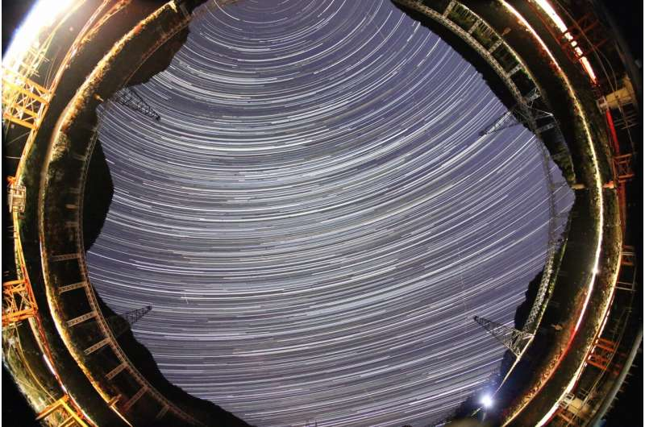

**ANCIENT "ALIEN-LIKE" EXPERIENCES ;** The preeminent work of one of the world's most accomplished linguists, Professor Kurt Schildmann (1909-2005) has disappeared from publication despite his profound completion of the greatest challenge faced in the study of Paleolithic culture worldwide. During his decades of travels and epigraphic research Schildmann was continually confronted with profoundly disturbing statements among the Illinois Cave archive's Paleo-Sanskrit texts, which repeatedly referred to those strange and prevalent phenomena involving unidentified circular spacecraft, 'alien' abduction, livestock mutilation and deep subterranean bases. Professor Schildmann's dedication to the translation of ancient hieroglyphic languages culminated in his 1994 recognition of the phonetic structure of Paleo-Sanskrit from the Indus Valley texts, a breakthrough enabling his definitive decipherment of the Indus Valley script, and by extension to the decipherment of the scripts of the Illinois cave archive and Tayos Cave, Ecuador. Schildmann's ability and willingness to link modern aerial phenomena with the enigmatic statements of ancient cultures has been met with strict suppression. The sole recognition for his achievements were offered by the Midwestern Epigraphic Society (MES) awarding Schildmann the 2007 Barry Fell Award (posthumous):

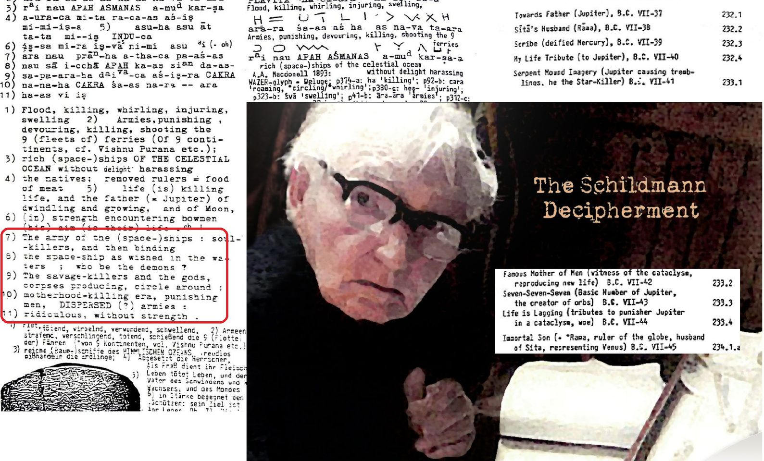

[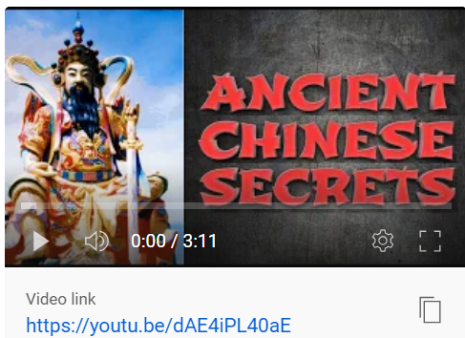](https://youtu.be/dAE4iPL40aE)

[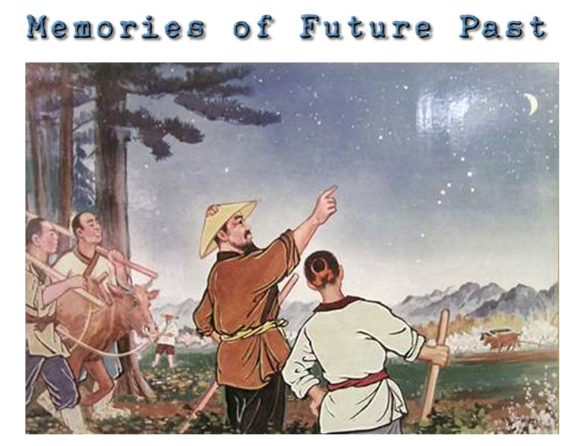](https://soundofstars.org/memoriesoffuturepast.htm)

**“It is a winter night and snow is whirling about the house.**

**Shao and his son sit and chat around the fireplace. Suddenly someone is knocking at the door. First there was a single knock, after a while, five in a row. Then a voice calls, "Shao, are you home? I want to borrow something from you.**

**Shao opens the door and the visitor enters with a burst of snow and wind. Shao already had a plan. He wants to see how good his son is with divination. He says to his visitor, "Don't say anything about what you want to borrow. I want my son to figure this out. Here, come over and make yourself comfortable around the fireplace."**

**Like father, like son - Shao's son is an I Ching student. No doubt he can start with the number of hour, day, month and year to develop a Pen Kua, Hu Kua and Shih Kua. But because this is a test of his skill, he wants to develop a new method of his own. He recalls that their visiting neighbour knocked on the door once then five times. He decides that is the clue and he calls the first knock the outer trigram Chien and calls the second group of five his inner trigram. Which comes to be Sun. It is past 10 at night so the hour is 22. To get the Moving Yao he adds one and five and 22 to get 28, and when divided by 6 the remainder is 4...**

**It is a very special case, for of the 6 trigrams there are 3 Qian and 3 aqre Sun. Qian is metal and Sun is wood. So the object their neighbour wants to borrow is related to wood and metal. So the son judges and says, "You want to borrow a hoe."**

**"You are wrong," says Shao, "He wants to borrow an axe." "What do you want to borrow!?" father and son ask the neighbour, almost in unison.**

[**"An axe," comes the reply.**](https://soundofstars.org/memoriesoffuturepast.htm)

**Shao smiles and explains to his son how he erred. Sun tends to represents something long, like a wooden handle. Qian stands for a round shape, especially of metal. A how usually is pointed or has a flat edge of metal, an axe always has a curved edge to cut wood better. But the two are close and Shao looks for another sign to confirm. Is it daytime? Then the visitor may use a hoe in daytime. Nighttime? This is impossible because there is no light for working outdoors in the garden I the middle of winter. Yet an axe, yes, maybe the neighbour needs to cut up some firewood. Shao decides for the axe. Its use is acceptable within the time of divination.”**

[**WIZARDRY 1-2-3**](https://soundofstars.org/wizardry123.htm)

[](https://soundofstars.org/wizardry123.htm)

“Previously, people led a calm and honest existence, detached from undue desire and  
ambition; they lived with an untainted conscience and without fear. They were active, but never  
depleted themselves. Because they lived simply, they knew contentment, as reflected in their diet  
of basic but nourishing foods, and clothing that was appropriate to the season but never luxurious.  
Since they were happy in their position in life, they did not feel jealousy or greed. They had  
compassion for others and were helpful and honest, free from destructive habits. They remained  
unshakable and unswayed by temptations, and they were able to stay centered even when  
adversity arose. They treated others justly, regardless of their level of intelligence or position.”

Huang Di asked, “I’ve heard of people in ancient times, spoken of as the immortals, who  
knew the secrets of the universe and held the world in the palm of their hands. They extracted  
essence from nature and practiced Qi Gong and various stretching and breathing exercises, and  
visualizations, to integrate body, mind and spirit. They remained undisturbed and thus attained  
extraordinary levels of accomplishment. [**Can you tell me about them?”**](https://soundofstars.org/wizardry123.htm)

**CURIOUS CASE OF ; Logic of Nature. A Synthesis of Thought (1909),**

**Missing manuscript……**

EXCERPTS ;

“… was privately printed and the limited run of 260 diagrams is suggestive of a project highly personal to Silva White as opposed to something intended for wider dissemination…”

Isolation in Thought of the Antithetical Positions & Inter-Relations of the Forces of Nature Illustrating Synthetic Unity of World-Conception or Correlation of Physical Processes & Physical Functions in the Evolution of Substance and Spirit Based on the Principle of the Immutable Mean by Arthur Silva White.

“..the letter reveals glimpses of a man keen to express himself in new and startling ways.”

There are four spheres or planes in the macrocosm:

lithosphere, hydrosphere, atmosphere, and ethersphere, which last-named is “the psychosphere of mind” – “the energy of thought”.

Matter is the vehicle of energy. Intelligence is at the root of things;

immanent Deity must be postulated. “Nature is the thinking-process of the God-head” – a striking and suggestive phrase…

Isolation in Thought

Posted *8 April, 2011 13:04* by [Karla Baker](https://web.archive.org/web/20120221133759/http:/blogs.nls.uk/bartholomew/?author=2)

Upon the commencement of John George Bartholomew’s tenure as director of John Bartholomew & Co. in 1888 there is a marked tendency towards the cartographic. The riotous miscellany which characterised earlier times was replaced by better and better mapping. However, there are always exceptions to this rule, with the subject of this entry being just such an exception.

On the **15 November 1909** Bartholomew printed 260 copies of a diagram, tongue-twistingly entitled *Isolation in Thought of the Antithetical Positions & Inter-Relations of the Forces of Nature Illustrating Synthetic Unity of World-Conception or Correlation of Physical Processes & Physical Functions in the Evolution of Substance and Spirit Based on the Principle of the Immutable Mean* by Arthur Silva White.

So who was Arthur Silva White and what is the meaning of his diagram? It is perhaps natural to place Silva White amongst the number of the ‘now forgotten’ British philosophical corpus. Intriguingly however, this is certainly not the case.

Arthur Silva White (1859-1932) was the first Secretary, magazine Editor and key founder member of the Royal Scottish Geographical Society. He is remembered in his obituary for his gift for language and his extensive knowledge of literature and geography. He had travelled widely, chiefly in diplomatic and official circles, and most especially in Africa. Other titles in his oeuvre include *The Development of Africa* (1892), *The Expansion of Egypt under Anglo-Egyptian Condominium* (1899) and *On the Achievements of Scotsmen During the Nineteenth Century in the Fields of Geographical Exploration and Research* (1889).

With credentials such as these it may come as no surprise that Silva White and John George Bartholomew were close friends. This friendship may go some way to explain the exception made by John George in terms of printing this highly non-cartographic item.

It is hard to say quite why Silva White produced something so far removed from his expertise. The work that this diagram was destined for, *Logic of Nature. A Synthesis of Thought* (1909), was privately printed and the limited run of 260 diagrams is suggestive of a project highly personal to Silva White as opposed to something intended for wider dissemination. Correspondence from Silva White to his old friend John George, sent in March 1909, reveals a man who is desperately keen to seek a more fulfilling life, following humbler pursuits. For five years Silva White had been Assistant Secretary to the British Association for the Advancement of Science but in this letter he writes that he has “chucked it in” and was thinking of starting a rose farm, despite knowing “nothing of rose-farming”. This is not to say that these events necessarily influenced *Logic of Nature* but nevertheless, the letter reveals glimpses of a man keen to express himself in new and startling ways.

So what of the diagram itself? Sadly the National Library of Scotland does not appear to hold a copy of *Logic of Nature* but we do have a review, printed in *Nature*, volume 83 (1910). Luckily for me it corroborates my initial and continuing impressions of this diagram (and by extension the work), being that it is extremely complicated and nigh on impossible to understand. The review reads thus, ‘This is an attempt to “outline a system of thought by which unity of world-conception may be predicated”…the pamphlet…is very tough reading even for those who have spent much time and thought on the subject. The following “heads”, however, will suggest the general drift. There are four spheres or planes in the macrocosm: lithosphere, hydrosphere, atmosphere, and ethersphere, which last-named is “the psychosphere of mind” – “the energy of thought”. Matter is the vehicle of energy. Intelligence is at the root of things; immanent Deity must be postulated. “*Nature is the thinking-process of the God-head*” – a striking and suggestive phrase…His conclusion is of course idealistic. “The ultimate reality of the sum of things cannot – so far as man is concerned – have existential import except in terms of thought; and therefore thought itself is the ultimate reality”. Perhaps in this there is a degree of concurrence and reference with the most famous philosophical statement of René Descartes “I think, therefore I am”.

The diagram is beautifully elegant, it hovers on the fringes of art; but the ideas that it conveys are extremely difficult. It seems to embody the culmination of fifty years of questioning and pondering and in so doing, illuminates an unexpected facet of a key member of the nineteenth century geographical cognoscenti.

[https://web.archive.org/web/20120221133759/http://blogs.nls.uk/bartholomew/?p=68](https://web.archive.org/web/20120221133759/http:/blogs.nls.uk/bartholomew/?p=68)

# [**This Superfluid Is Alive, And It Could Power Machines of the Future**](https://www.youtube.com/watch?v=v9C45gUwh38)

](https://soundofstars.org/explorations.htm#articles)

**THE HIGHER YOU ARE, THE FASTER YOU AGE**

**](https://soundofstars.org/emotionalsymptoms.htm)**